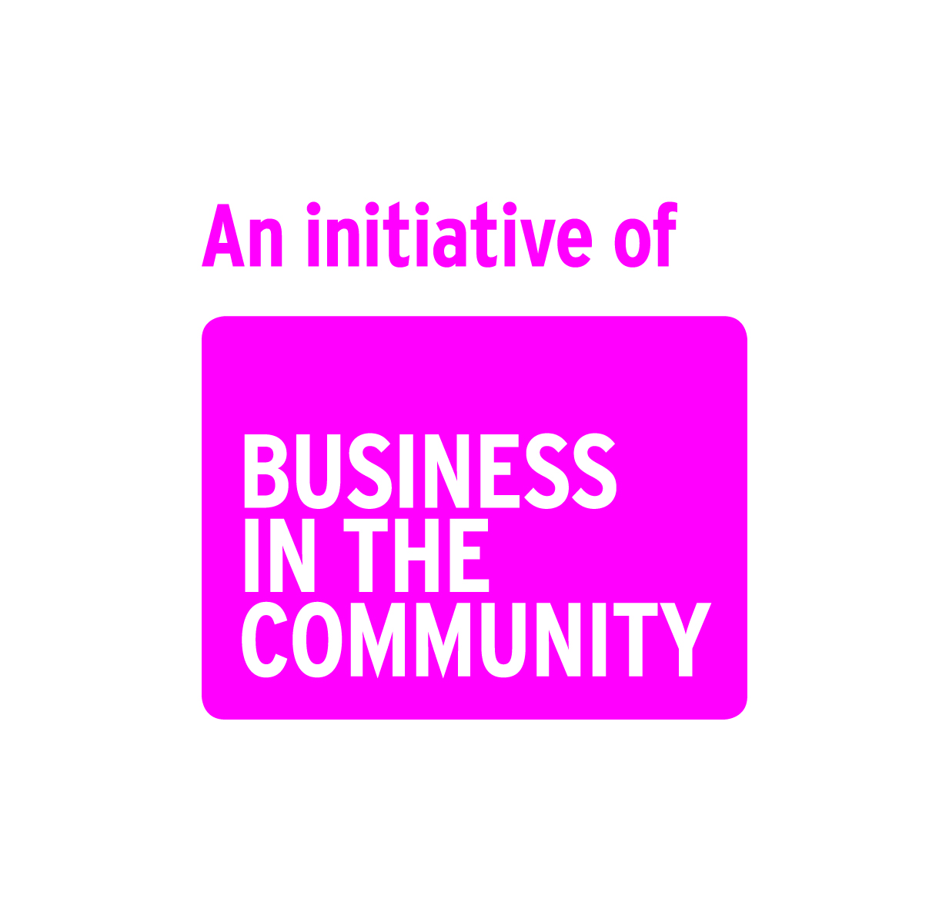

Work Inspiration at <<<Insert Company Name>>>
Student handbook

This template handbook forms part of the ‘Work Inspiration Toolkit’. It has been designed in Word so you can easily tailor it to your businesses needs and corporate style.

The handbook is the key document that the student will keep with them during the placement and fill in at the end of each day. It helps them keep all the key details in one place.

Please be aware that this is just guide and the Health and Safety aspects in particular, must be carefully considered and tailored to suit your workplace.

“If Work Inspiration didn't exist I would be doing a media course at college and not getting the hands on experience with the company like I am now.”
ITV Apprentice

Template welcome message
Thank you for joining us at <<<Insert company name>>>,

I remember my first day, I felt a little nervous but the team made me feel very welcome and I have loved working here ever since.

We have designed this ‘Work Inspiration’ week with you in mind to give you a real insight into what it’s like to work here. But it isn’t just about you finding out about us, we want you to find out what you are good at and achieve things you will feel proud of.

So listen and learn from your new colleagues, use your initiative and really show us what you’ve got.

Your ‘Work Inspiration’ journey is about to start.

Good Luck!

<<<Insert chief executive signature>>>
<<<Insert company name>>>

Contents
- About us
- About you - expectations and goals
- The ten student commitments
- Key contacts
- My placement timetable
- Induction and safety quiz
- Daily learning logs
- My Personal Action Plan

About us
<<<Insert some text here to explain in layman’s terms what your business is about to help the student understand what you do, how you do it and who you do it for. Talk about the range of careers available in your industry>>>

About you – what are your expectations and goals?

Write down what you hope to get out of your placement? What skills do you hope to learn?

Write down your expectations; what do you think it will be like to work here?

The ‘Ten Student Commitments’
The <<<Insert company name>>> Work Inspiration programme has ten commitments that we want you to make so that you have a really inspiring placement.

Before my placement I will…
- Discuss with my school teacher the skills I hope to learn on my work placement

During my placement I will…
- Listen carefully to the induction and safety briefing and complete the quiz, so I can work safely during my placement
- Always behave in a courteous and professional manner
- Be punctual and notify my Supervisor/Buddy by 9.00am if I’m going to be late or absent for any reason
- Meet with my Supervisor/Buddy at the end of each day to reflect on what I have learned and discuss any concerns
- Complete a project and present it back to the team
- Have fun!
After my placement I will…
- Discuss with my school what I learned and how the placement matched my expectations.
- Feedback my views on the placement
- Make a Personal Action Plan, to help me work towards my goals after my placement

I have understood the commitments and I agree to follow their principles

Student signature: Date:

……………………………...... ………………….

4. Key contacts

Key contacts for the placement
Dates of placement:

Name of student (CAPITALS):

Student signature:

Emergency contact details:

Contact at school details:

Contact at provider details:(if applicable)
Co-ordinator / Buddy:

My placement time table
Use this timetable to make a note of things like tasks or who you’ll be meeting, when and where.

Mon 6th | Activity | Who + Where
Morning
Afternoon
Tues 7th | Activity | Who + Where
Morning
Afternoon
Wed 8th | Activity | Who + Where
Morning
Afternoon
Thurs 9th | Activity | Who + Where
Morning
Afternoon
Fri 10th | Activity | Who + Where
Morning
Afternoon

Additional notes:

Induction and safety quiz

While you are working with us, you will be treated as a <<<Insert company name>>> employee and this comes with certain responsibilities, one of them that we take very seriously is safety. You must follow our codes of conduct while on your placement, and you have a legal responsibility to comply with Health and Safety legislation. Listen very carefully to the induction and safety briefing and answer the questions below so that we know that you will be safe during your placement with us.

Question: | Answer:
My Supervisor/Buddy’s name is…
My nearest fire exit is…
If my Supervisor/Buddy isn’t around I can contact….
The site contact number is…
The fire drills take place at …
The fire assembly point is….
If I have an accident, or see a safety hazard then I must report it to….
The exit is located….
The toilets are located….
I leave my coat and bag at…
If I am sick or late I have to contact .. | Who?:……………………………………...….  By what time?:……………..
The dress code is ….
Lunch/breaks will be spent in….
My hours of work are…
Length of breaks… | Morning?...............…..Afternoon?.......................Lunch?....................
Supervisor/Buddy declaration:
I have ensured that the student understood fully the induction and safety briefing.
Supervisor/Buddy signature:

……………………………......
Supervisor/Buddy name (CAPITALS): Date:

……………………………...... ………………………….
Student declaration:
I have understood the induction and safety briefing and agree to abide by the code of conduct.
Student signature

……………………………......
Student name (CAPITALS) Date:

……………………………....... ………………………….
Reflective learning log - Day 1
Use this section to write in your own words what you achieved and what you learned each day.

What did you do today?

What are you most proud of?

What did you learn about <<<Insert company name>>> ?

What did you learn about yourself?

What did you learn about how others work? What skills did they need to have to do their job?

What do you need to prepare for tomorrow, so that it is even better than today?

Supervisor/Buddy review - Day 1

Your supervisor or buddy will fill out this section with you at the end of each day. This is just a guide to help you think about the employability skills and behaviours you have developed, (so don’t worry if you can’t fill in every box!)

People Skills: Listening, Diplomacy | Positive ‘Can-do’ attitude
Application of information technology | Determination
Application of numeracy | Problem-solving  Creativity
Self-management | Attention to detail
Communication Skills: Persuasion, body language, phone, email | Business and Customer awareness
Team-work | Planning/Goal Setting  Decision-making
How would you write what you learned today on your CV?
Are there any other skills or attributes you demonstrated during the day?

Reflective learning log - Day 2
Use this section to write in your own words what you achieved and what you learned each day.

What did you do today?

What are you most proud of?

What did you learn about <<<Insert company name>>>?

What did you learn about yourself?

What did you learn about how others work? What skills did they need to have to do their job?

What do you need to prepare for tomorrow, so that it is even better than today?

Supervisor/Buddy review - Day 2

Your supervisor or buddy will fill out this section with you at the end of each day. This is just a guide to help you think about the employability skills and behaviours you have developed, (so don’t worry if you can’t fill in every box!)

People Skills: Listening, Diplomacy | Positive ‘Can-do’ attitude
Application of information technology | Determination
Application of numeracy | Problem-solving  Creativity
Self-management | Attention to detail
Communication Skills: Persuasion, body language, phone, email | Business and Customer awareness
Team-work | Planning/Goal Setting  Decision-making
How would you write what you learned today on your CV?
Are there any other skills or attributes you demonstrated during the day?

Reflective learning log - Day 3
Use this section to write in your own words what you achieved and what you learned each day.

What did you do today?

What are you most proud of?

What did you learn about <<<Insert company name>>>?

What did you learn about yourself?

What did you learn about how others work? What skills did they need to have to do their job?

What do you need to prepare for tomorrow, so that it is even better than today?

Supervisor/Buddy review - Day 3

Your supervisor or buddy will fill out this section with you at the end of each day. This is just a guide to help you think about the employability skills and behaviours you have developed, (so don’t worry if you can’t fill in every box!)

People Skills: Listening, Diplomacy | Positive ‘Can-do’ attitude
Application of information technology | Determination
Application of numeracy | Problem-solving  Creativity
Self-management | Attention to detail
Communication Skills: Persuasion, body language, phone, email | Business and Customer awareness
Team-work | Planning/Goal Setting  Decision-making
How would you write what you learned today on your CV?
Are there any other skills or attributes you demonstrated during the day?

Reflective learning log - Day 4
Use this section to write in your own words what you achieved and what you learned each day.

What did you do today?

What are you most proud of?

What did you learn about <<<Insert company name>>>?

What did you learn about yourself?

What did you learn about how others work? What skills did they need to have to do their job?

What do you need to prepare for tomorrow, so that it is even better than today?

Supervisor/Buddy review - Day 4

Your supervisor or buddy will fill out this section with you at the end of each day. This is just a guide to help you think about the employability skills and behaviours you have developed, (so don’t worry if you can’t fill in every box!)

People Skills: Listening, Diplomacy | Positive ‘Can-do’ attitude
Application of information technology | Determination
Application of numeracy | Problem-solving  Creativity
Self-management | Attention to detail
Communication Skills: Persuasion, body language, phone, email | Business and Customer awareness
Team-work | Planning/Goal Setting  Decision-making
How would you write what you learned today on your CV?
Are there any other skills or attributes you demonstrated during the day?

Reflective learning log - Day 5
Use this section to write in your own words what you achieved and what you learned each day.

What did you do today?

What are you most proud of?

What did you learn about <<<Insert company name>>>?

What did you learn about yourself?

What did you learn about how others work? What skills did they need to have to do their job?

What do you need to prepare for tomorrow, so that it is even better than today?

Supervisor/Buddy review - Day 5

Your supervisor or buddy will fill out this section with you at the end of each day. This is just a guide to help you think about the employability skills and behaviours you have developed, (so don’t worry if you can’t fill in every box!)

People Skills: Listening, Diplomacy | Positive ‘Can-do’ attitude
Application of information technology | Determination
Application of numeracy | Problem-solving  Creativity
Self-management | Attention to detail
Communication Skills: Persuasion, body language, phone, email | Business and Customer awareness
Team-work | Planning/Goal Setting  Decision-making
How would you write what you learned today on your CV?
Are there any other skills or attributes you demonstrated during the day?

8. My Personal Action Plan
It takes planning to achieve your goals. Fill out your Personal Action Plan below and keep it in a safe place so you can refer to it in the months ahead, to make sure you are on track to achieve your goals.

This is the Personal Action Plan of …………….……………….………………
What are my goals for the future?
What do I need to think about to achieve these goals?
What college/university/traineeships/apprenticeships are going to help me to reach my goals?
What will I need to do when I am back in school, to work towards these goals?
What are my actions for this month?
What are my actions for the next year?
What is the first thing that I need to do next to make things happen?

“I really enjoyed meeting and finding out about all the different people and their jobs, it has given me a great insight into Boots UK itself, but also what I would like to do with my future, thank you again”
Boots Work Inspiration Student

Copyright © Business in the Community 2015

