MY SKILLS CHECKER

The purpose of this resource is to help you identify what areas you want to focus on in your coaching sessions. It will ask you to reflect on essential skills, digital skills, employability skills, wellbeing and goal setting.
By discussing the questions and responses together, you will begin to build an understanding of what is of most importance to you during these coaching sessions.
Please talk through each question together and complete the responses. Keep a copy and/or email it, as this resource might be a useful reference in your final session as you reflect on your six coaching sessions and your coaching experience overall.

Contents

Essential Skills 2
Digital Skills 4
Employability Skills 5
Wellbeing 6
Goal Setting 6

Essential Skills
How confident are you with using your listening skills?
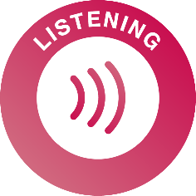
This skill is all about being able to effectively receive information - whether it comes from customers, family members or work coaches.

I think I am

(not confident at all, not very confident, somewhat confident, very confident, extremely confident)
I think this because… (what is your experience of using them)

How confident are you with using your speaking skills?
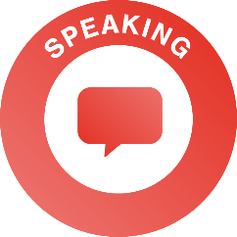
This skill is all about how to communicate effectively with others, being mindful of who you are talking to, and in what setting.
I think I am

(not confident at all, not very confident, somewhat confident, very confident, extremely confident)
I think this because…

How confident are you with using your problem-solving skills?
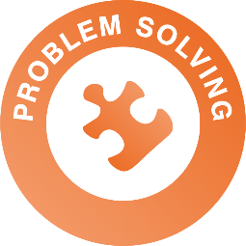
This skill focuses on how to solve problems, recognising that there are transferable tools that you can develop and use. This might look like completing tasks, exploring problems and creating plans.
I think I am

(not confident at all, not very confident, somewhat confident, very confident, extremely confident)
I think this because…

How confident are you with using your creativity?
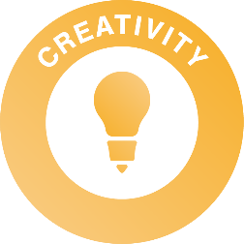
This skill is all about generating innovations or ideas which can then be honed through the problem-solving process. This might be generating ideas yourself or supporting others with their ideas.
I think I am

(not confident at all, not very confident, somewhat confident, very confident, extremely confident)
I think this because…

How confident are you with staying positive?
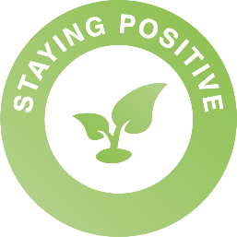
This skill is all about being equipped to manage your emotions effectively and being able to remain motivated, and ultimately to motivate others, even when facing setbacks.
I think I am

(not confident at all, not very confident, somewhat confident, very confident, extremely confident)
I think this because…

How confident are you with aiming high?
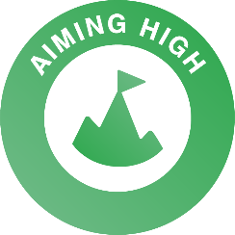
This skill is all about individuals being equipped to manage your emotions effectively and being able to remain motivated, and ultimately to motivate others, even when facing setbacks.
I think I am

(not confident at all, not very confident, somewhat confident, very confident, extremely confident)
I think this because…

How confident are you with using your leadership skills?
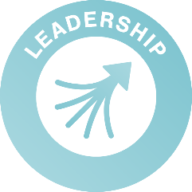
This skill is relevant not only for individuals in positions of management with formal power, but also for individuals working with peers in teams. This involves managing tasks and managing others.
I think I am

(not confident at all, not very confident, somewhat confident, very confident, extremely confident)
I think this because…

How confident are you with using your teamwork skills?
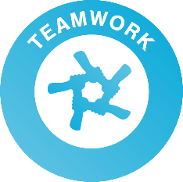
This skill is about fulfilling expectations around being positive, behaving appropriately, being timely and reliable and taking responsibility. This involves working well with others, contributing to a group and improving/influencing a team.

I think I am

(not confident at all, not very confident, somewhat confident, very confident, extremely confident)
I think this because…

Digital Skills
Here are some examples…
Using technology for researching and applying to jobs

Using technology in work
Using Word to update your CV
Searching for jobs online
Using email to submit a job application

Filling in online application forms

Online interviews (video calls)

Using LinkedIn

How confident are you with your digital skills?
I think I am

(not confident at all, not very confident, somewhat confident, very confident, extremely confident)

An area of digital skills that I would like to develop is:

Employability Skills
Here are some examples…
Having a good CV
Doing well in interviews
Coping with rejections and knock-backs
Learning new skills or re-train for a different job
Finding a job
Knowing the job market
Knowing the types of jobs that are suitable for your skillset
Writing a cover letter

How confident are you with your employability skills?
I think I am

(not confident at all, not very confident, somewhat confident, very confident, extremely confident)

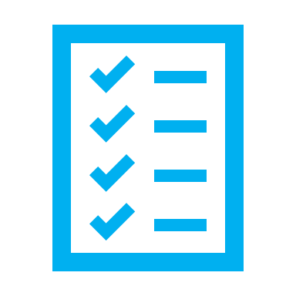
An area of employability skills that I would like to develop is:

Wellbeing
“I feel optimistic about my chances to find work.”
None of the time ☐ Rarely ☐ Some of the time ☐ Often ☐ All of the time ☐
How would you rate your motivation in looking for work?
No motivation at all ☐ Very little motivation ☐ Moderate motivation ☐ Strong motivation ☐
Very strong motivation ☐

Goal Setting
Note to coaches: this is a starting point for your discussions that will be explored in more depth during session two.

As you reflect on the answers given throughout this resource, discuss/consider which areas you think would be good to focus on.
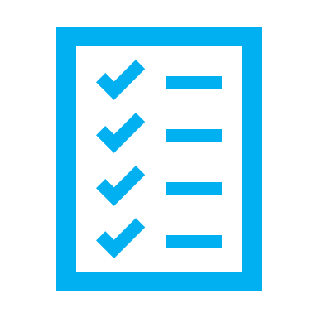
What would you list as your goals for these six coaching sessions? Write down at least two in the boxes below.
At the end of these six coaching sessions, I would like to:
4.

3.

2.

1.

