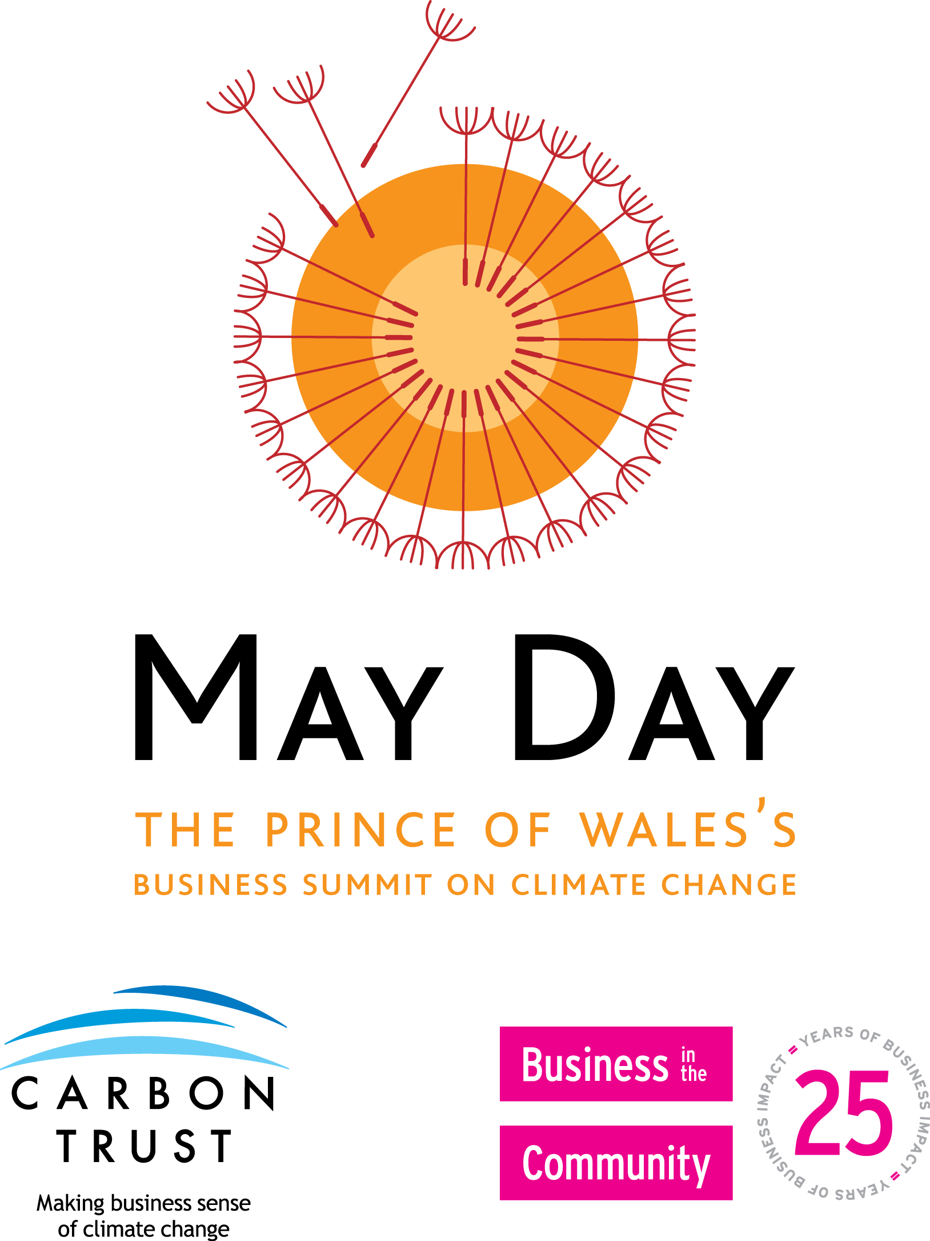
The Prince of Wales’s
May Day Business Summit on
Climate Change
May 1st 2007

Agenda

              9.00 – 9.30am | Arrival and registration
9.30 – 10.10am | Welcome and introduction to the day
10.10 – 10.20am | Welcome from HRH The Prince of Wales
 | Broadcast via video-conference from St James’s Palace
10.20 – 10.35am | Existing attitudes towards climate change
 | Delegates will have the chance to put across their views about climate change by answering a series of questions with anonymous personal voting equipment. The collated results of these questions will be instantaneously displayed at each event
10.35 – 11.00am | Climate change – the scientific consensus
 | Presentation from leading scientist about the facts of climate change, broadcast from St James’s Palace
 | Table discussions
11.00 – 11.20am | The climate change quiz hosted by Stephen Fry
 | Broadcast from St James’s Palace
11.20 – 12.30pm | The impacts of climate change
 | Presentation from Jonathon Porritt on the impacts of climate change and the challenges and opportunities that exist for businesses in a low carbon economy, broadcast from St James’s Palace
 | Table discussions on what a low carbon economy will mean for UK business
 | Plenary feedback from table discussions
12.30pm | Lunch

The Prince of Wales’s
May Day Business Summit on
Climate Change

1.30 – 1.40pm | Feedback from around the nation
 | Feedback via video-conference from a number of regions on highlights from table discussions
1.40 – 2.40pm | Taking action on climate change
 | Table discussions about the actions business can take to tackle climate change. This will give delegates the opportunity to share experiences of climate change initiatives within their company and to discuss in detail the actions their company could take
 | Plenary feedback from table discussions
2.40 – 2.55pm | Feedback from around the nation
 | Feedback from a number of regions on key actions and initiatives
2.55 – 3.10pm | Commitment to action
 | Delegates will be asked to pledge to take action on climate change and will be offered support in following up their pledges after the Summit
3.10 – 3.20pm | Attitudes towards climate change
 | Delegates will be asked again to give their views about climate change via polling questions. The collated results of these questions will be displayed and compared with the morning’s results
3.20 – 3.30pm | Closing remarks and thanks from HRH The Prince of Wales
 | Broadcast from St James’s Palace to all regions
3.30 – 4.30pm | Afternoon refreshments

